Connect to SDLC VM and Run SDLC Blockchain App

Note: These instructions are assuming you are using a Windows 10 computer to connect to the virtual machine. If you are on Mac or Linux there are likely some extra configurations that will have to perform before following this tutorial, and likewise some steps may be different on older Windows versions. As the app evolves some of the screens will change.

First open the “Remote Desktop Connection” application. (e.g. hit the windows key and type it out, then click on the link). A box like the below should come up. Since I have connected to the VM before its name already pops up automatically.

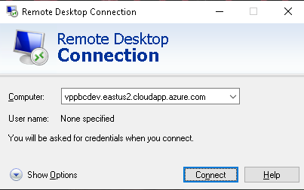

Enter either the DNS name above (vppbcdev.eastus2.cloudapp.azure.com) or the exact IP address: 13.68.24.112. You may receive a warning about connecting to an unknown computer, ignore it and connect.

When you connect you will see a screen like this:

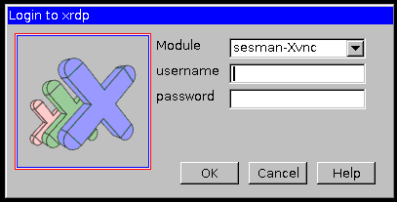

Provide the VM credentials here. The username is vpp_BlockchainAdmin. For security purposes, please consult with the Blockchain group or John Vorchak for the password.

Once you login you should see a screen like the below if you authenticated successfully. If not you will see a “login failed” message. You may also see a strange moving screen that doesn’t look like the below, if so move the mouse, it is a screensaver.

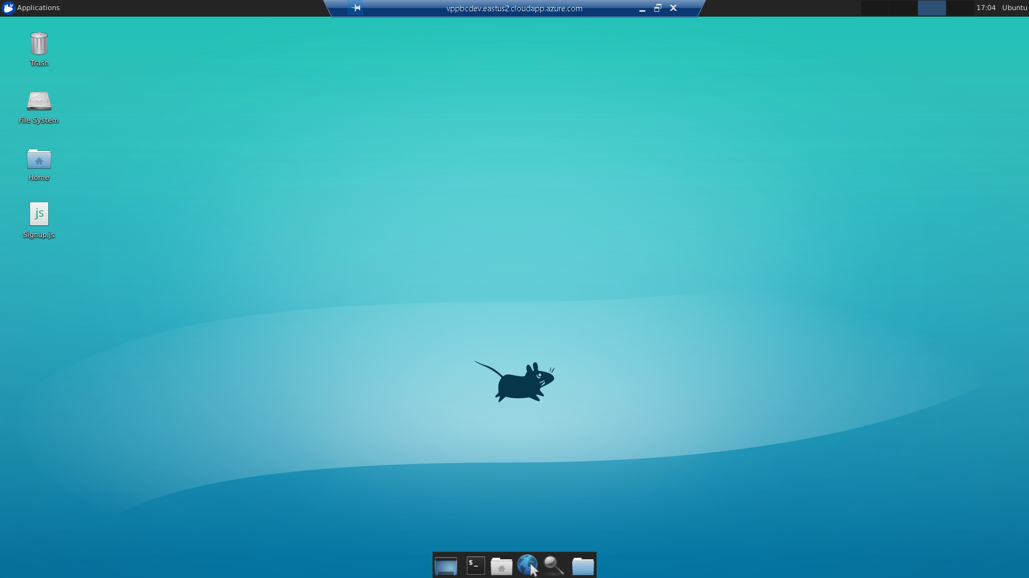

At the bottom of the screen in the middle is an application try. Then click on the little folder icon (3rd from the left). You should see a screen like the below:

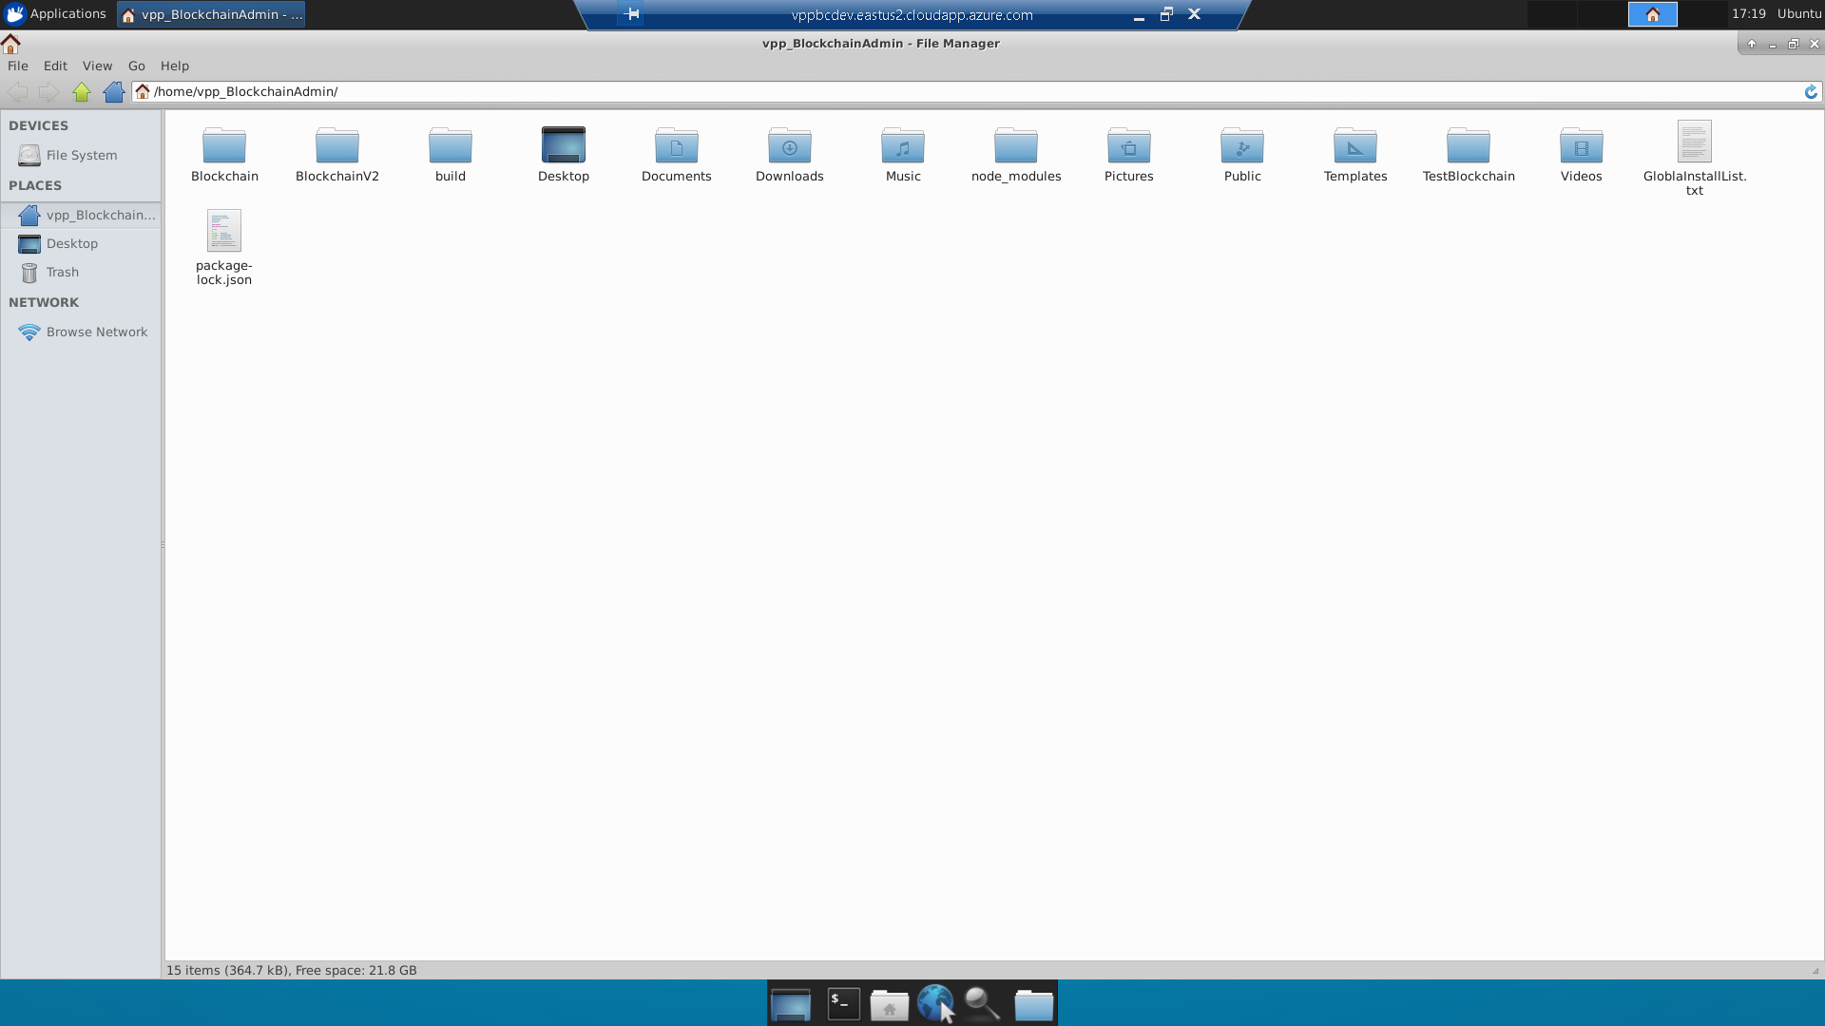

This is the file directory. As of writing, we will be working with the “BlockchainV2” folder. We will run the app via the terminal, but it is useful to use the GUI to better visualize what we are running and where.

Navigate to this directory in the GUI either by clicking on each part of the path or entering the path in the address bar up top.

/home/vpp_BlockchainAdmin/BlockchainV2/SDLC_Blockchain_Demo-master/project_code_base/

This is the main path we will be using to run the app. A picture of it is below:

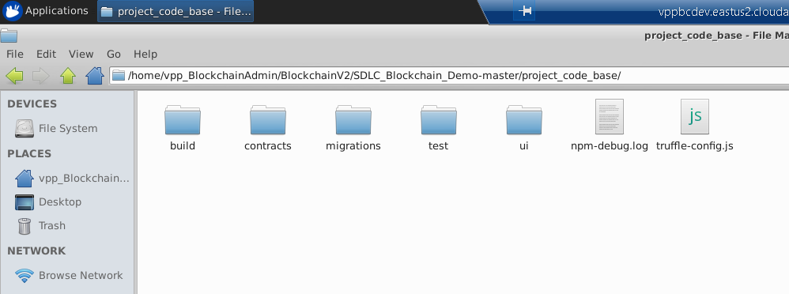

Now open a terminal (click the icon second from the left in the bottom tray or hit Control + Shift + T). To switch between applications, use Alt + Tab. You can also click the appropriate application tab at the top left of the screen.

Now we need to get to the same path in the terminal that we currently are in the GUI. One of the easier ways to do this is to do the following: First type “cd” in the terminal. Then highlight the full path in the GUI. Then with the terminal open and visible (alt + tab if only one is visible), put your mouse pointer in the terminal past the previously typed “cd”. Now click the scroll wheel on your mouse (if it has a button, click it, otherwise use it like it was a button). If your mouse does not have a scroll wheel, you can press the left and right mouse buttons simultaneously. If done correctly, the path should have pasted onto your terminal line. Press enter. Now the full path will show to the left of your terminal.

If this method does not work for you, you can always type out the path. An easy way is to go one part at a time. So start with cd “/home/”, then cd “vpp_BlockchainAdmin”, then cd “BlockchainV2”, and so on and so forth until you are in the “project_code_base” folder. You can enter “ls” in between each command to look at the contents of your current directory.

No matter which way you get there, the end result looks like the below:

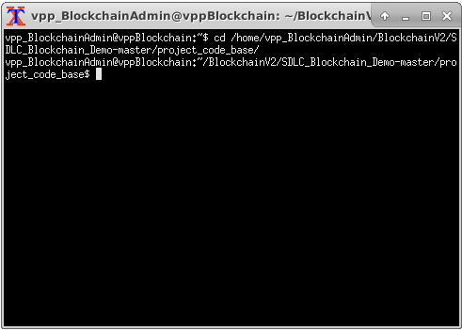

Now type “truffle compile” into the terminal and hit enter. You may see a few lines of messages that says something like this “Compiling someContract.sol…”. Whether you see them or not you are good.

Now open another terminal (click the GUI or control shift T). You may have to Alt + Tab to open the appropriate terminal. For this new terminal you don’t need to be in a specific directory. Now in the new terminal type the following: “ganache-cli –b” and hit enter. You should see a screen like the below. The full screen is below; you may only see the bottom.

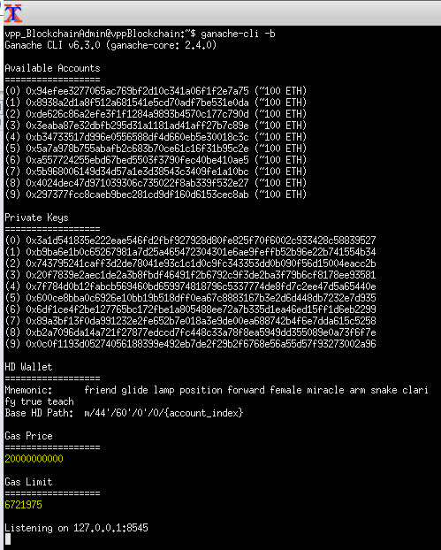

This screen means you have started running a test Blockchain. Some of these details will change instance to instance, such as the Mnemonic. Note: From now on, I will call this the “Blockchain terminal” and the other the “project terminal”.

Now go back to the project terminal, type “truffle migrate” and hit enter.

Both terminals should respond, and will look something like the following image. Note: I put the terminals together on one screen by moving one to the far left and the other to the far right, and then maximizing them. You may want to do this to avoid having to cycle back between terminals using Alt + Tab or tabs.

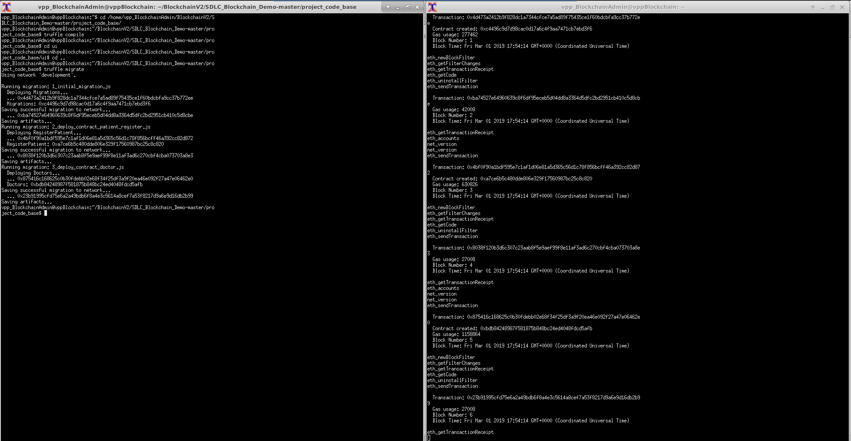

Go back to the project terminal (on the left in the above). Type in “cd ui” and press enter. You will now be in the “ui” directory. It is vital that you are in the “ui” directory for the next step; it will not work without it.

Now type “npm start” and press enter in the project terminal. This will start the application. You will see output both on the terminal and an internet browser that will automatically open. The terminal will say “Starting the development server…”. If successful, you will see the app and the terminal will indicate “Compiled with warnings”. See the below image, where I put the terminal and the browser app in the same screen.

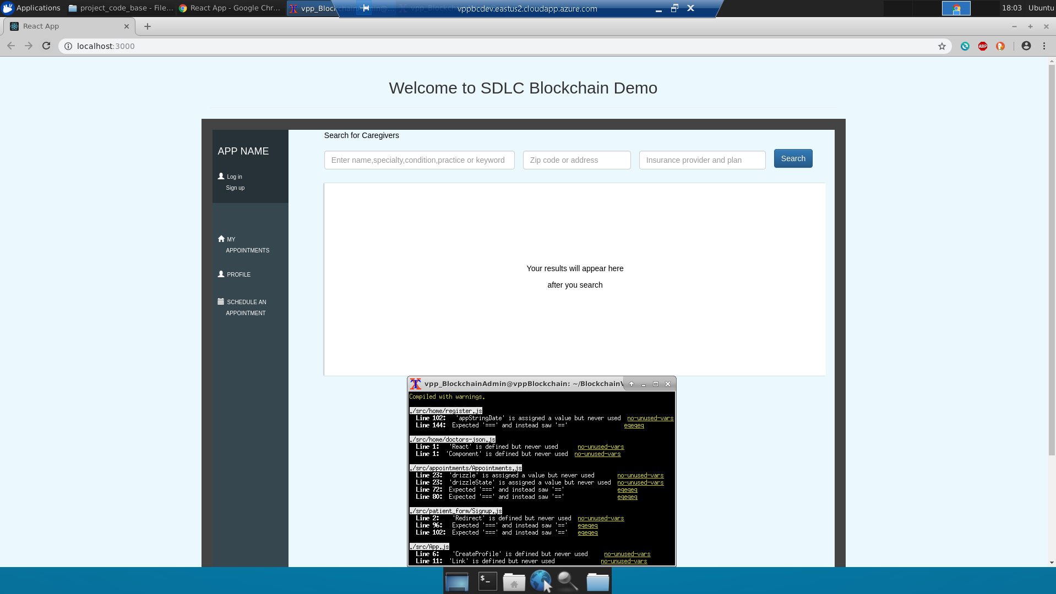

Congratulations, you are now running the SDLC Blockchain application. The following steps are likely to change as the app evolves, but for tutorials sake I will quickly walk through a few of the app screens. I minimized the terminal screen for that part.

In the upper left, click “search”. You should see a screen like this:

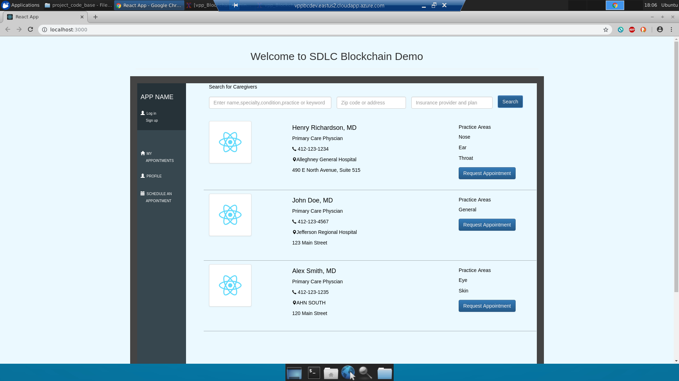

Now click “Request Appointment” on any of the doctors. You will be prompted for an appointment date, like the below screen. Note the app will already detect the present date (I made this tutorial on 3/1/2019).

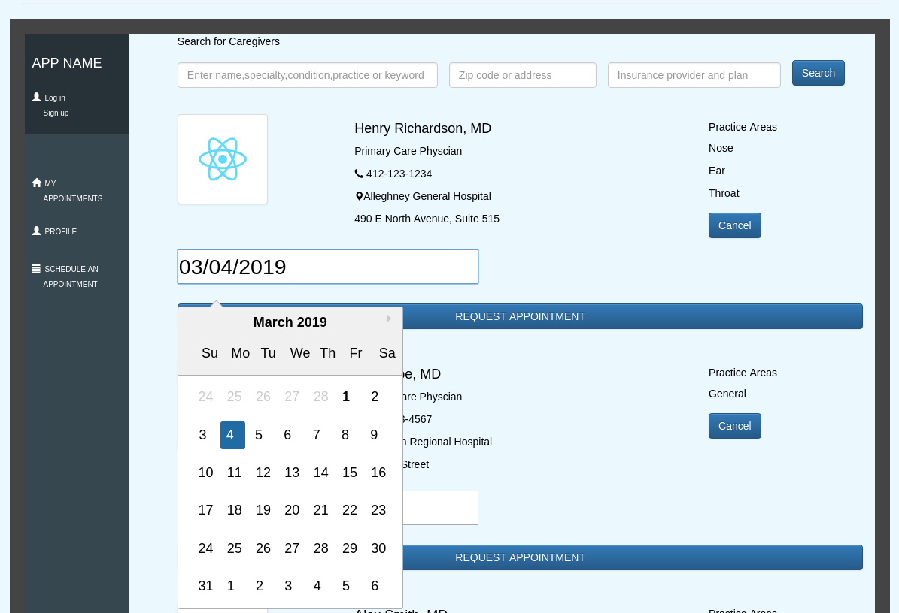

Now click “request appointment”. You will see a screen like this:

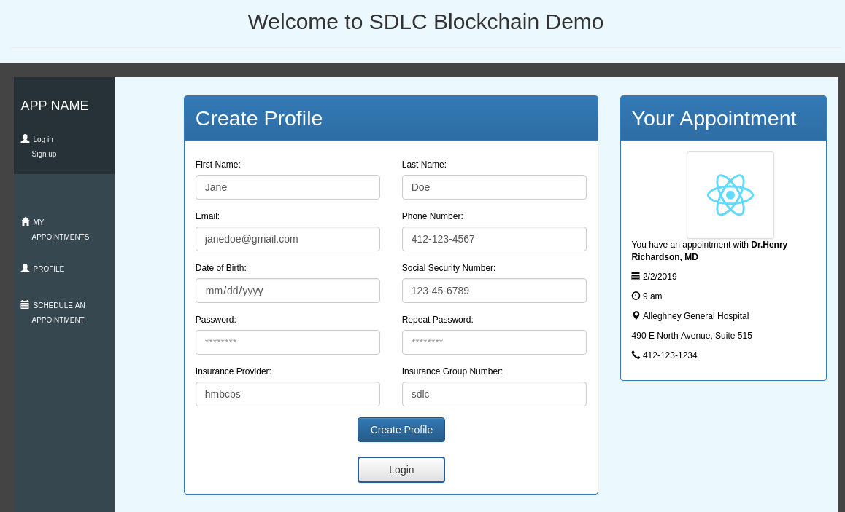

For now this will be the end of my walkthrough for the app itself. The next portion is about stopping the app’s execution for further runs.

Go to both terminal and type Control + Z to stop the process. Exit the browser as well.

Another way to shut everything down is to use the following commands in either the directory terminal or a separate new terminal.

“fuser –n tcp –k 3000”

“fuser –n tcp –k 8545”.

The project has portions running on two ports, 3000 for the app itself and 8545 for the blockchain. These commands kill these processes. If successful, the appropriate terminal will say “Killed”. The project terminal may throw errors since it isn’t expecting to be killed, that is fine.

If you are done, exit the connection by clicking the “X” at the middle right in the blue bar. You may be prompted with a box saying “Your remote session will be disconnected”. If so just click ok.

You can also just leave the connection idle and it will eventually close itself and give you an error.